Chapter 6, Solution 55.

(a) L//L = 0.5L, L + L = 2L

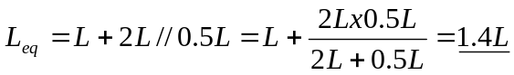= 1.4 L.

(b) L//L = 0.5L, L//L + L//L = L

L_{eq} = L//L = 500 mL

